CMPE 314

Fall 2019

Lab 2:Diode-Based Filtered Rectifier and Regulator Circuits

Joshua Bastian

Purpose

The purpose of this Lab is to analyze filtered rectifier circuits. In this lab we analyze them theoretically and experimentally using a Zener diode regulator circuit. In the lab we will try to determine the proper resistance for the filter.

$$V_{r}=V_{m}/(2fRC)$$

Where f-frequency, $V_{m}$- amplitude of sinusoid signal, R- resistance, C-capacitance

Equipment

Procedure

1.Construct the circuit in Figure 1 using a 741 op amp to buffer the sinusoidal signal generator. The opamp should be powered with 10V and -10V. According to the pin diagram connect the op amp refer to the data sheet.

2. Connect two oscilloscope probes CH1 and CH2 respectively to Vin and Vl and set the measure the peak to peak.

3. Set the input signal to be a 10V peak to peak value, 60Hz freq waveform., On the oscilloscope the scales should be 5ms/div and 1V/div

4. Vary the potentiometer until the output voltage ripple is less than 10%. Measure the Resistance of the potentiometer using a multi meter

This next procedure is in Cadence

5. Build the circuit in Cadence (by pass the op amp) Input a sinusoidal signal (freq = 60Hz and peak to peak 10V) to the circuit, Sample the output waveform, What is the ripple voltage?

6. Add an Zener diode in parallel to the capacitor in Figure 1, repeat steps 5 and 6 and what are the Ripple Voltages respectively

Data/Measurements:

Experimental:

$R_{L} measured 50K ohms$

Prelab:

$$R_{L} calculated 13k ohms$$

Graphs:

Filter Rectifier Circuit with output voltage ripple at 10%

Experimental:

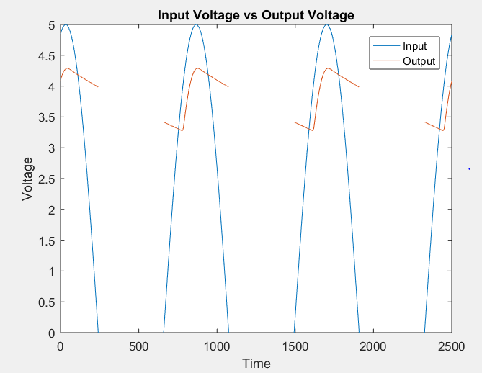

Theoretical:

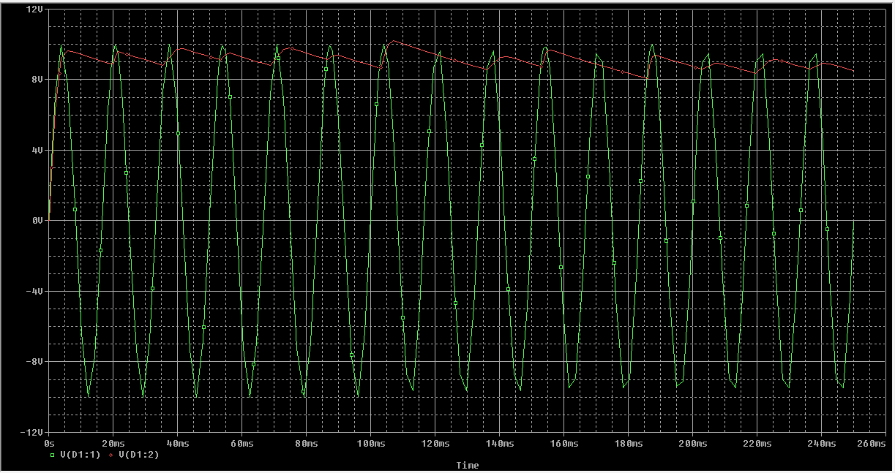

Figure 2 Schematic on Cadence

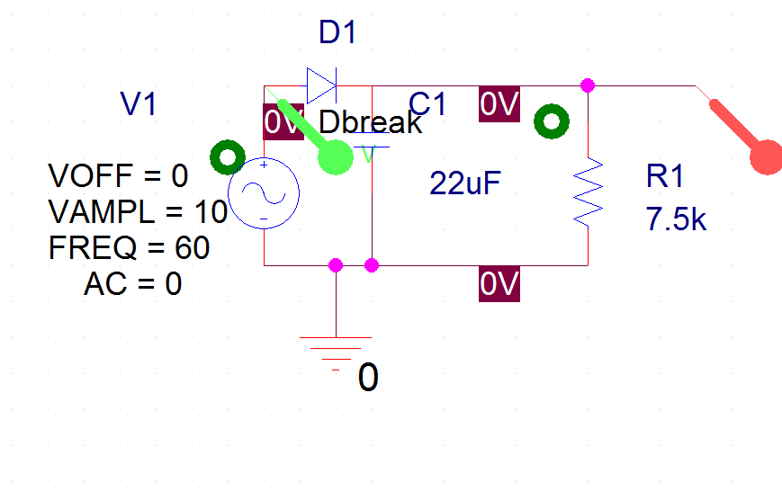

Calculations:

$V_{r}=\frac{V_{m}}{2fRC}$ $(\frac{1}{10})V_{m}=\frac{V_{m}}{2*60*R*(22µF)}$ R= 13kohms

Conclusion:

In this lab we used a filtered rectifier circuit to convert an AC waveform into a near DC wave form. In the experimental analysis we observed higher resistance in the filter, caused the ripple voltage to be less that 10%.Our load resistance measured was 50kohms which varies from the theoretical value by 40%. This margin of error can be due to the internal resistance of the components. Many applications of this filter are radios, televisions, and computer equipment that require a constant steady DC voltage.